Vectors- Mark Scheme
May 2019 Mathematics Advanced Paper 1: Pure Mathematics 1

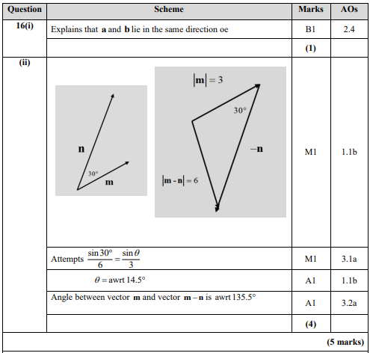
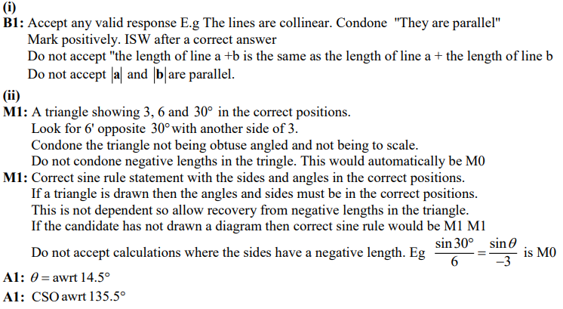
May 2018 Mathematics Advanced Paper 1: Pure Mathematics 1

